**EXPERIMENT 7**

Q1. LOGISTIC REGRESSION IMPLEMENTATION ON IRIS DATASET

ANS.

import numpy as np

import pandas as pd

import matplotlib.pyplot as plt

from sklearn.linear_model import LogisticRegression

from sklearn import metrics

from sklearn.model_selection import train_test_split

a = pd.read_csv("/content/Iris (1).csv")

print(a)

feature_columns = ['SepalLengthCm', 'SepalWidthCm', 'PetalLengthCm','PetalWidthCm']

X = a[feature_columns].values

Y = a['Species'].values

X_train, X_test, Y_train, Y_test = train_test_split(X, Y, test_size=0.3)

lr = LogisticRegression(C=100.0, multi_class='ovr')

lr.fit(X_train, Y_train)

Y_predict = lr.predict(X_test)

print(metrics.accuracy_score(Y_test, Y_predict)*100)

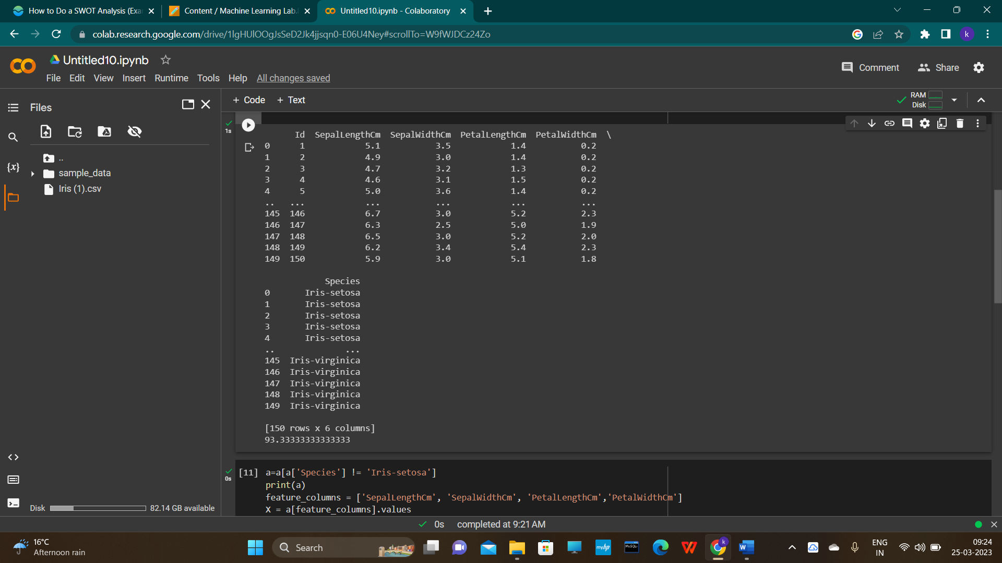

AFTER REMOVING ONE CLASS ( SETOSA ) IN CONTINUATION WITH THE UPPER CODE -

a=a[a['Species'] != 'Iris-setosa']

print(a)

feature_columns = ['SepalLengthCm', 'SepalWidthCm', 'PetalLengthCm','PetalWidthCm']

X = a[feature_columns].values

Y = a['Species'].values

X_train, X_test, Y_train, Y_test = train_test_split(X, Y, test_size=0.3)

lr = LogisticRegression(C=100.0, multi_class='ovr')

lr.fit(X_train, Y_train)

Y_predict = lr.predict(X_test)

print(metrics.accuracy_score(Y_test, Y_predict)*100)

